# **Business Analysis Capstone Project**

# Restaurant Management System – The Grill House

By – Radhika Jha



**Project Task: Week 1  (This is on the Business Analysis concepts taught)**

1. Identifying Stakeholders – Create a list of Stakeholders (as taught in Business Analysis Planning and Monitoring Knowledge Area)
2. Create As-Is and Future Process map (using flowcharts). You can use any of the popular tools in the market like Microsoft Visio, Lucidchart, Creately, Pidoco, or Balsamiq
3. As a Business Analyst working on this project, find out the scope of the Restaurant Management Software. Write down the main features that need to be developed.
4. Write the in-scope and out-of-scope items for this software.
5. Write out the business requirements, both functional and nonfunctional requirements.
6. Draw wireframes or mock screens for two of the features namely *menu creation* and *table reservation*. Use the technique prototyping or wireframing that is taught in the training. You can use any of the wireframing tools like Microsoft PowerPoint, Microsoft Word, Balsamiq, Sketch, Adobe XD, Adobe ILLustrator, Figma, UXPin, InVision Studio, Invision Freehand, or Moqups.

**Project Task: Week 2 (This is on the agile scrum concepts taught)**

1. Make a product backlog of user stories for the given case study. User Stories should be in the format of As a <type of user>, I want <goal> so that <reason>
2. For each story, write the acceptance criteria.

**(This is on the Tableau concepts taught)**

1. Create a dashboard for senior management to view sales of restaurants for the last six months. Make assumptions as appropriate and create the dashboard using your own mock data.
2. Create a dashboard to show which zone (Zone 1, 2, 3, or 4) has highest sales. Make assumptions as appropriate and create the dashboard using your own mock data.

1. Create a bar graph for San Jose, Madison, and New York showing the sales. Label the chart drawn correctly so that senior management gets a clear report of sales.
2. Arrange the data above in excel in an ascending and descending order for each city.

Question 2:

1. In the above chart for restaurant ID 1200789, find the sales for the month of June
2. In the above chart for restaurant ID 1200739, find the sales for the month of April
3. In the above chart for restaurant ID 1200352, find the sales for the month of January

Stakeholders – Onion peel diagram / Stakeholder Map via stakeholder matrix

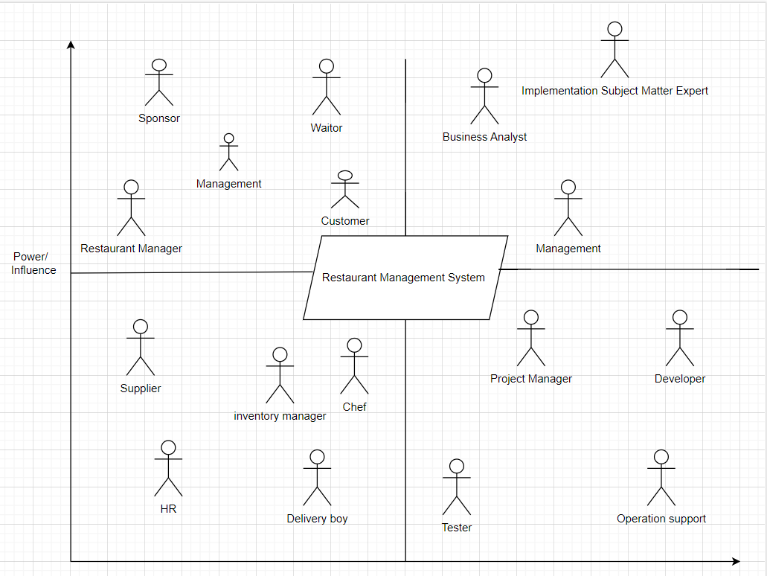

AS IS MODEL

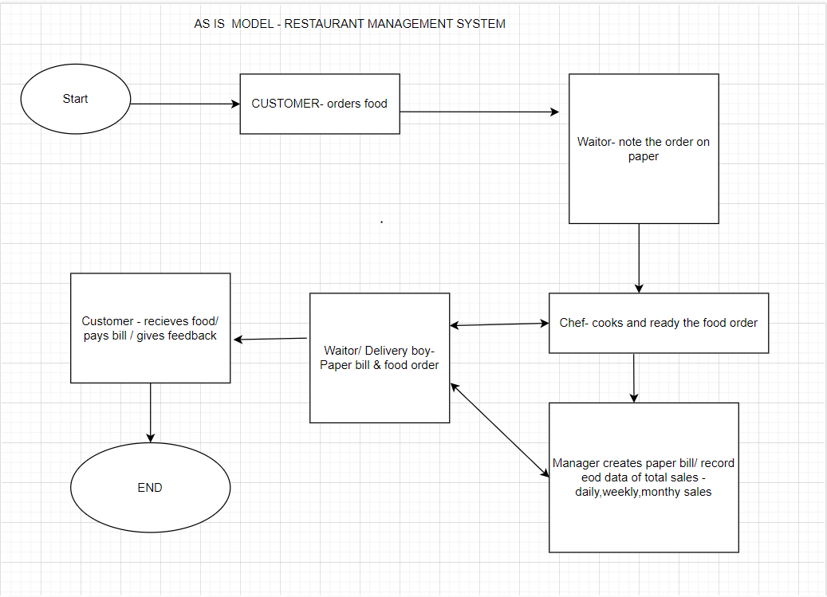

To Be Model

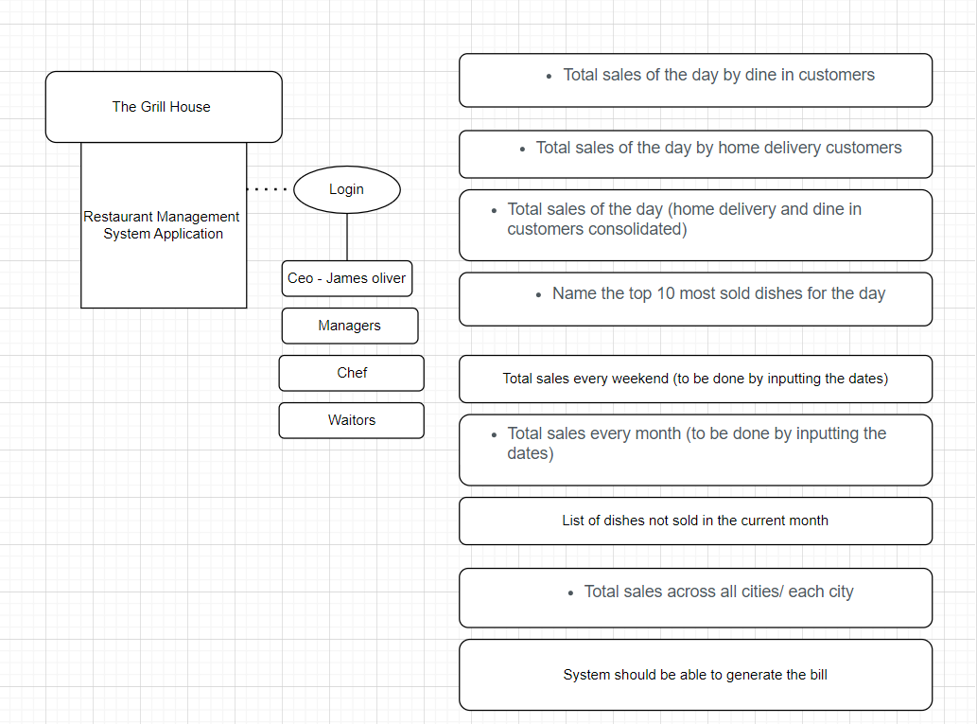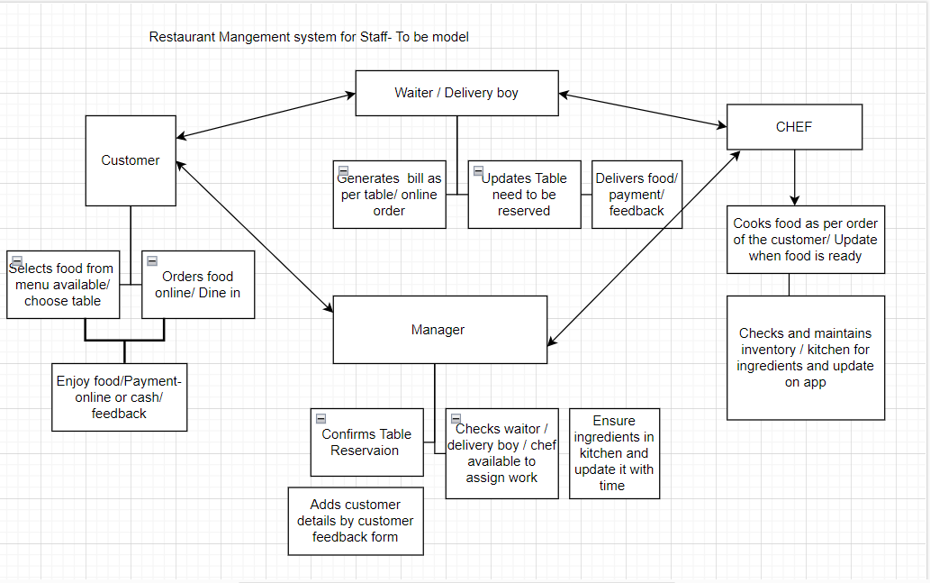

UML DIAGRAM

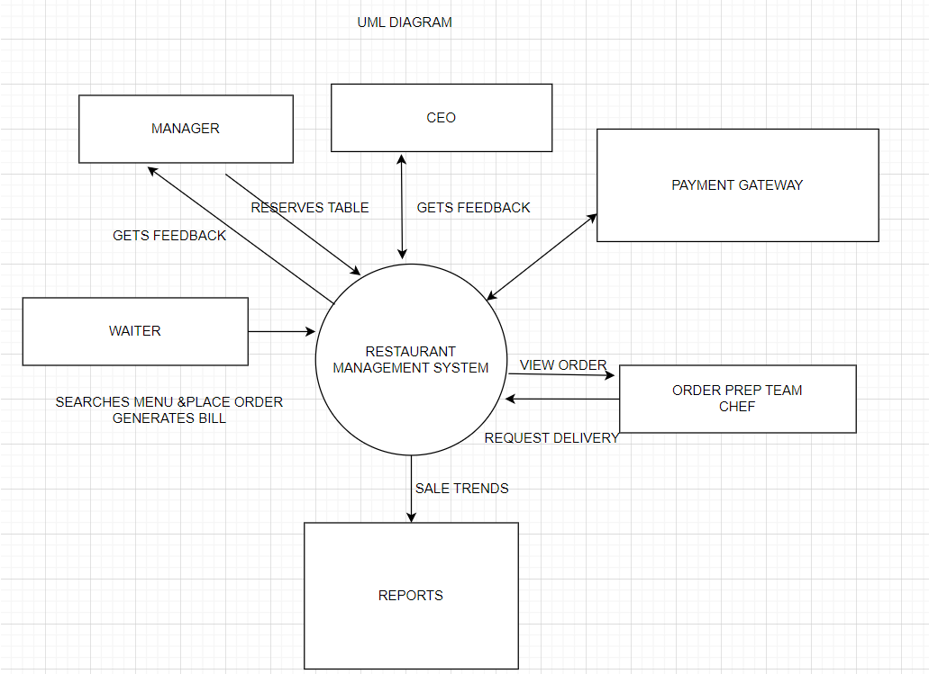

IN SCOPE & OUT OF SCOPE ITEMS FOR THIS SOFTWARE

|  |  |
| --- | --- |
| In scope | Out of scope |
| View menu | Prepaid payment |
| Order meal |  |
| View order |  |
| Edit order |  |
| View order status | Request for inventory and supplier |
| Order delivery to customer |  |
| Payment gateway |  |
| Create /update menu |  |
| Table selection/Reservation |  |
| Generates bill |  |
| Customer feedback/comments |  |
| Reports/ data |  |

Business Requirements

* The Grill House chain of restaurants are all across USA. On an average each restaurant has a few hundred daily dine in and take out customers.
* The manual paper-based management of the restaurant is causing several issues. The waiters take orders on paper and a paper-based bill is presented to the customers. These bills are entered at the EOD by the manager into excel to know the total sales and item wise sales for the day. Reports are created using the excel file to know the sales trends or know popular dishes and dishes not doing well.
* The management has decided to transition from a manual process to an automated restaurant management system so they can better track sales and manage their daily business better.
* The objective here is to have an automated online system for restaurant management, allowing them to efficiently use of its resources to increase productivity and sales. The reports generated in a timely manner will show sales trends to make better business decisions.
* This can capture customer feedback.

**Functional Requirements:**

* All Employee details should be stored in the system. Employee information is verified by the system prior to setting up login credentials.
* The waiter can open the web page of the Restaurant Management System. He/she can select a table for seating customers, search menu, place order, generate customer bill, process payment and print a feedback form.
* The waiter can check available tables and select a table for dine in customers to be seated.
* The waiter or manager can search the menu for a specific dish.
* Manager can create and update the menu.
* Manager can reserve tables.
* The restaurant Manager (the Grill House employee) can create the menu and update the menu for his restaurant.
* The waiter can select the dishes the customer would like to get and create an order. They should be able to edit the items on the customer order before placing order. Waiter can add more items before generating the bill.
* Once the order is confirmed and submitted, waiter should **NOT** be able to cancel or edit the order.
* The restaurant manager should be able to view the orders placed by the waiters. He shall take an inventory of all the dishes ordered and give them to the chef for cooking.
* Once the chef has prepared the dishes the restaurant manager should be able to request the waiter to deliver the dishes to the dine in customer table.
* Once the customer is done with his meal. The waiter will give the customer the generated bill.
* The bill generated should have the waiter ID and table number.
* The waiter will take the customer payment as either cash or credit card. The credit card payment will be processed using a payment gateway.
* The waiter or manager will give the customer a feedback form.
* For home delivery orders the take out order is prepared by the chef. There shall be a home delivery employee (delivery boy) who shall deliver the order to the customers address. Bill is generated and placed with the home delivery order. A feedback form is also given with the order. The customer can pay with credit card over the phone or give cash to the delivery boy. After delivering the order and customer payment, the manager shall close the customer order.
* The home delivery generated bill will have the customers name, customers phone number and customers address.
* Once the customers give back the feedback forms. The Manager can enter the feedback form information into the system.
* Management would like the following reports:
* Which dishes are the most popular?
* Satisfaction of the customers on the quality of service. This

should be tracked based on feedback submitted by the customers.

* Total sales of the day by dine in customers.
* Total sales of the day by home delivery customers.
* Total sales of the day (home delivery and dine in customers consolidated).
* Name the top 10 most sold dishes for the day.
* Total sales every weekend (to be done by inputting the dates)
* Total sales every month (to be done by inputting the dates)
* List of dishes not sold in the current month (this is to phase out dishes that customers are not ordering).
* Total sales across all cities.
* Total sales for each city.
* Order forecasting i.e. a prediction of which items will be ordered and when they will be ordered.

**Non-Functional Requirements:**

* **Usability**: The screens should be self-explanatory and very user friendly.
* **Scalability & Performance**: This restaurant management system is required to support a volume of 2500 employees across all states in USA. The web pages should be accessed quickly and information should be available fast.
* **Availability**: System should have high performance, must be efficient and be 99% available.
* **Security***:* Users are validated before creating login id.
* **Service level Agreement:** Inventory supplies data, Order forecasting.
* **Compliance***:* HR compliances and policy.

**Interface**: The system is to be created and maintained in Java. Java will not change much over time, and if the system is developed well, the code will need very little maintenance.

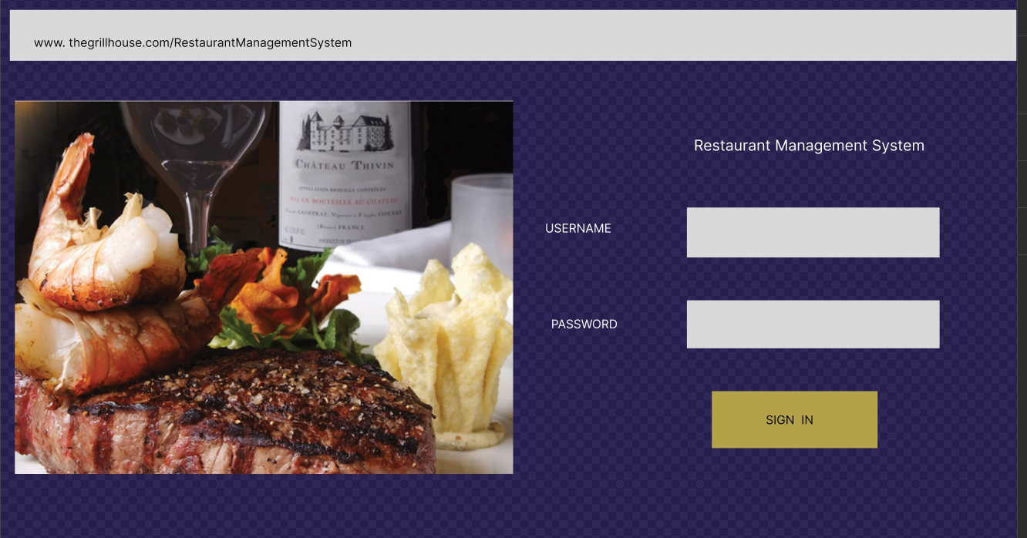

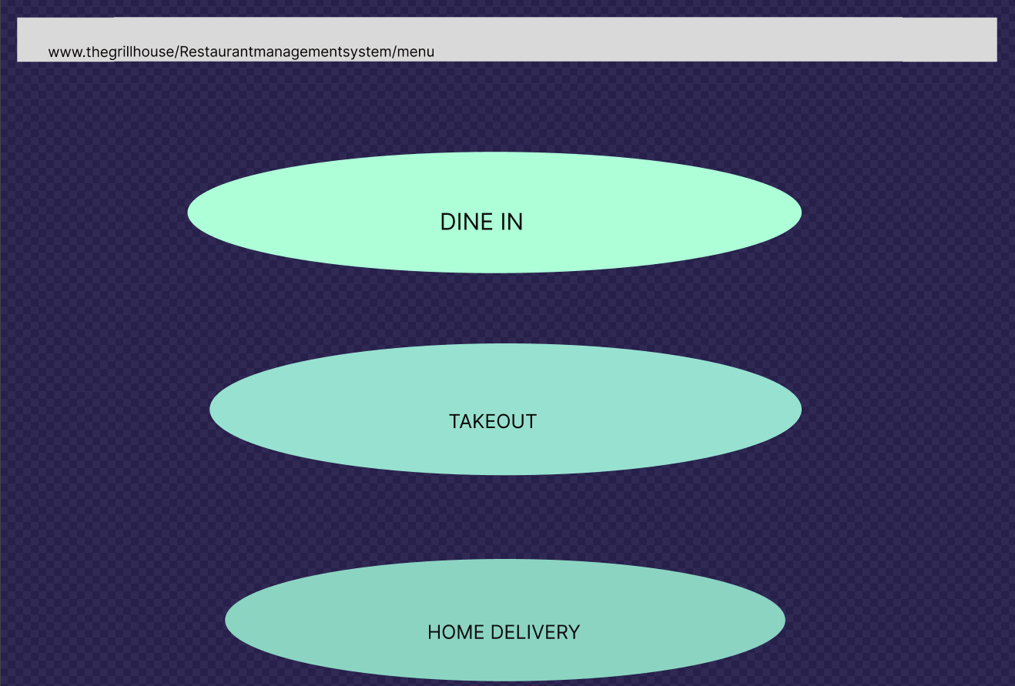

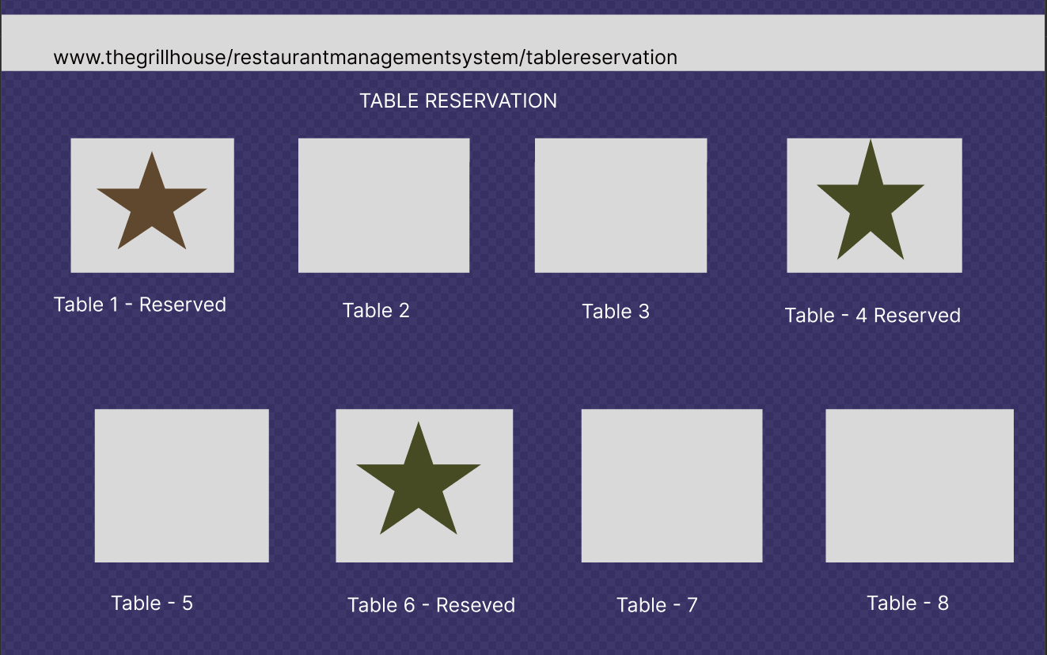

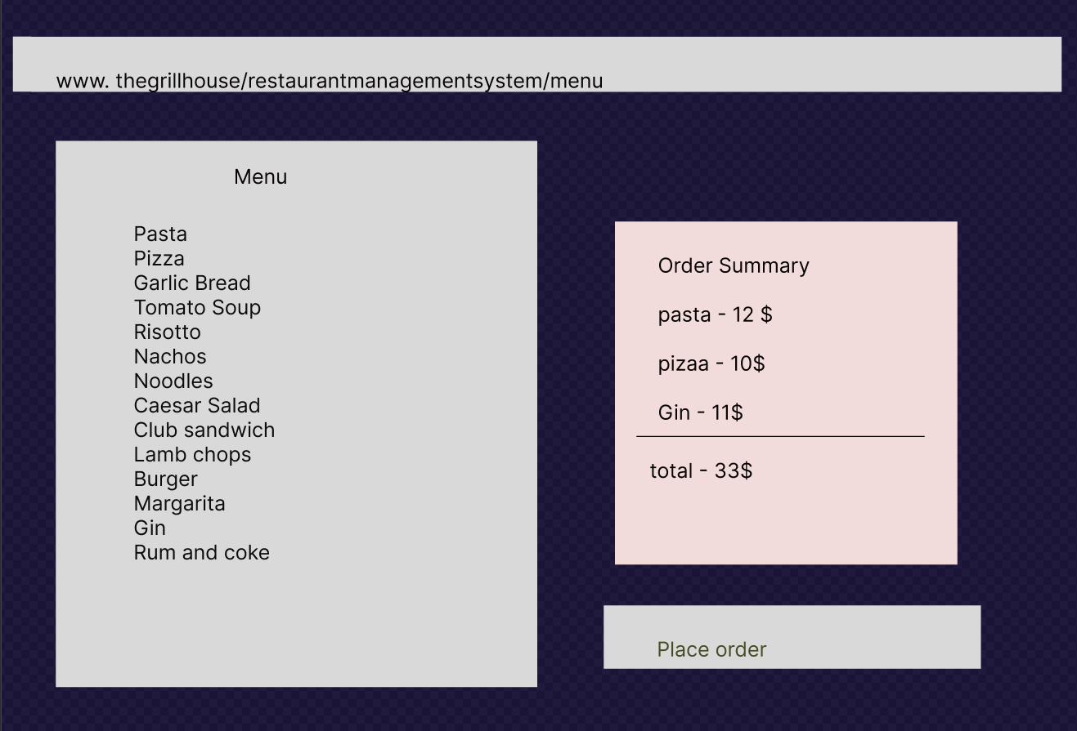

***Conclusion:*** The Online Restaurant Management System should achieve the business objectives on release.

**Business Objective 1:** Improved management of the restaurant chains by allowing access to the managers to update menu, make take reservations and keep track of sales. Waiters can place orders based on the most current menu and bill customers with accuracy.

 Scale: Value is quality of service and time saving.

* Previous – paper-based bills

**Business Objective 2:** Reduced restaurant operating costs by 15% within 6months, following initial release.

**Business Objective 3:** Increased average effective work time by 30 minutes per waiter per day, and increased manager work time by 1 hour within 3 months.

**Business Objective 4:** The reports will be generated faster due to information being available immediately and this will help in knowing the sales trends to make better planning and menu decisions.

**Business Objective 5:** The management can make better decisions with customer feedback.

#### **Product Backlog**

|  |  |  |  |  |  |
| --- | --- | --- | --- | --- | --- |
| Title | State | Backlog Priority | Story Points | Acceptance Criteria | Iteration Path |
| As a user I want to create an account so that I can use the Restaurant Management system. | Approved | 9 | 2 | Given that the user has access to the application. If the user is a valid employee (waiter, manager or other) then the account can be created otherwise display “Account cannot be created”. | Release 1- Sprint 1 |
| As a user I want to change password so that I can reset it. | Approved | 9 | 1 | A user is able to change password when he enters his old password and is allowed to create a new password. When the new password is entered it should be 8 characters long and it should have 1 character, 1 number and 1 special character. | Release 1- Sprint 1 |
| As a waiter I want to search the menu so that I can lookup dishes and prices. | Approved | 5 | 4 | When on the application the user is able to locate search. The user enters any value and the value will be displayed. | Release 1- Sprint 1 |
| As a manager I want to add new items, delete existing items, as well as create new menus from scratch so that the menu is accurate. | Approved | 3 | 5 | When the manager is on the application, they should be able to locate the Menu. They can add, delete or edit any items and prices on the menu. | Release 1- Sprint 1 |
| As a waiter I want system access so that I can place customer order. | Approved | 3 | 2 | When on the application the waiter should be able to locate the order menu and select dishes to place the customer order. | Release 1- Sprint 2 |
| As a waiter I want system access so that I can generate bills table wise. | Approved | 4 | 2 | When on the application the waiter should be able to locate the bill option and generate the bill. | Release 1- Sprint 2 |
| As a waiter I want to generate the bill tagged to me (the waiter generating it) and the table number so that it can be tracked. | Approved | 4 | 2 | When on the application the waiter should be able to select the table so that both table name and waiter id is on the generated bill. | Release 1- Sprint 2 |
| As a manger I want to reserve tables so that they can be booked. | Approved | 7 | 3 | When the manger is on the application, he can select tables and reserve them for customers. | Release 1- Sprint 3 |
| As a waiter I want to look into the software to determine which tables need to be reserved so that I can seat dine in customers. | Approved | 6 | 2 | When on the application the waiter should be able to search for tables available and select the table to seat customers. | Release 1- Sprint 3 |
| As a waiter or manager, I want to access to payment gateway on the system so that customers can pay by cash or card. | New | 4 | 4 | When the user is on the application they can take customer payments by cash or credit card using the payment gateway. | Release 1- Sprint 3 |
| As a CEO I want feedback form given to every customer so that details like name, address, mobile number, email, date of birth, anniversary dates of the customers, and their feedback can be captured. | New | 5 | 4 | When on | Release 1- Sprint 3 |
| As a manager I want to manually enter customer details like name, address, mobile number, email, date of birth, anniversary dates and their comments so that the customer feedback & information can be stored in the system. | New | 6 | 4 | When on the application as a manager I should be able to locate the feedback form for printing and be able to enter the information from the feedback form into the system. | Release 1- Sprint 4 |
| As Management I want reports on sales trends at the EOD so that decisions can be made. | New | 3 | 8 | When on the application the management should be able to generate reports showing sales trends. | Release 1- Sprint 4 |

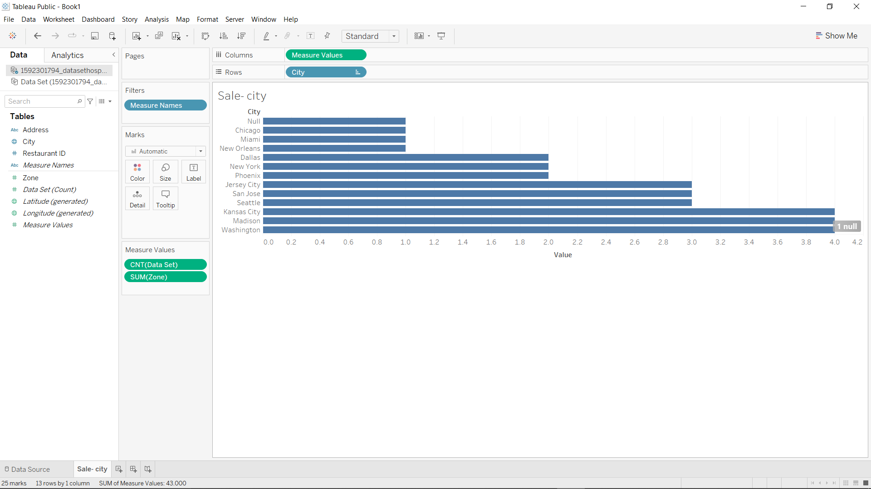

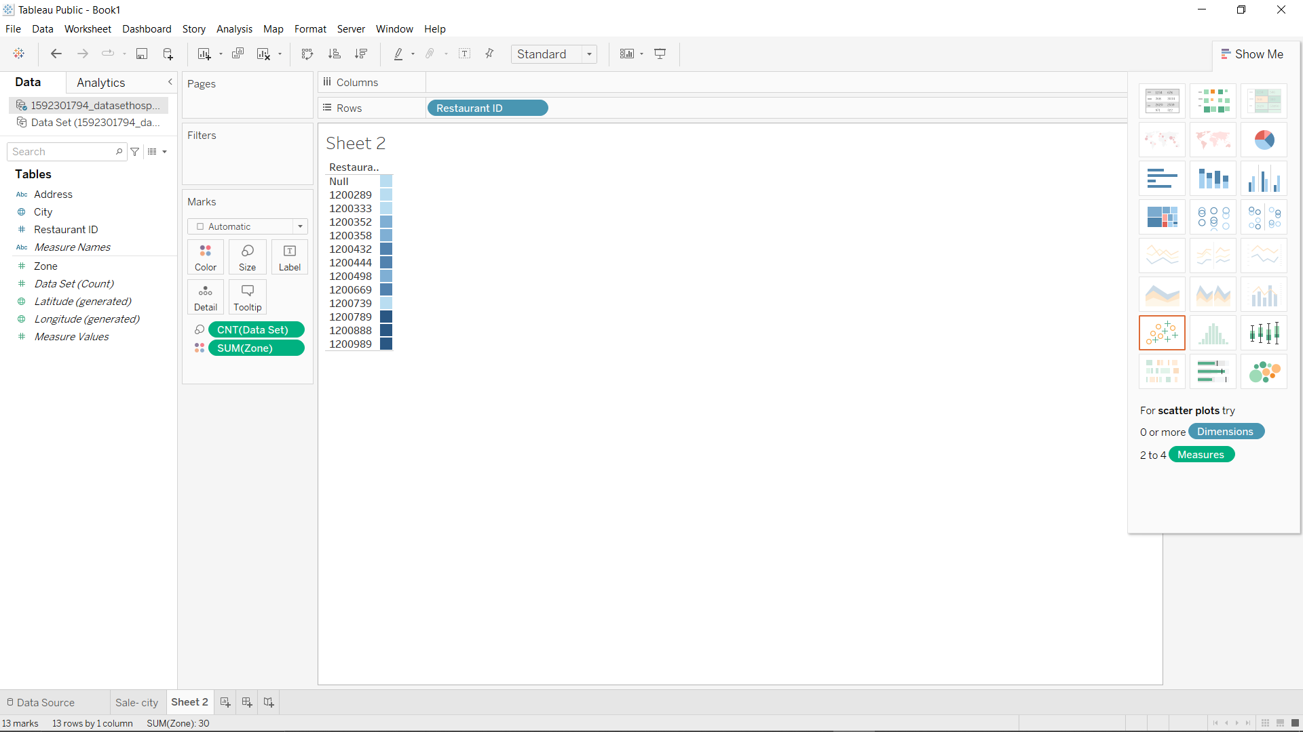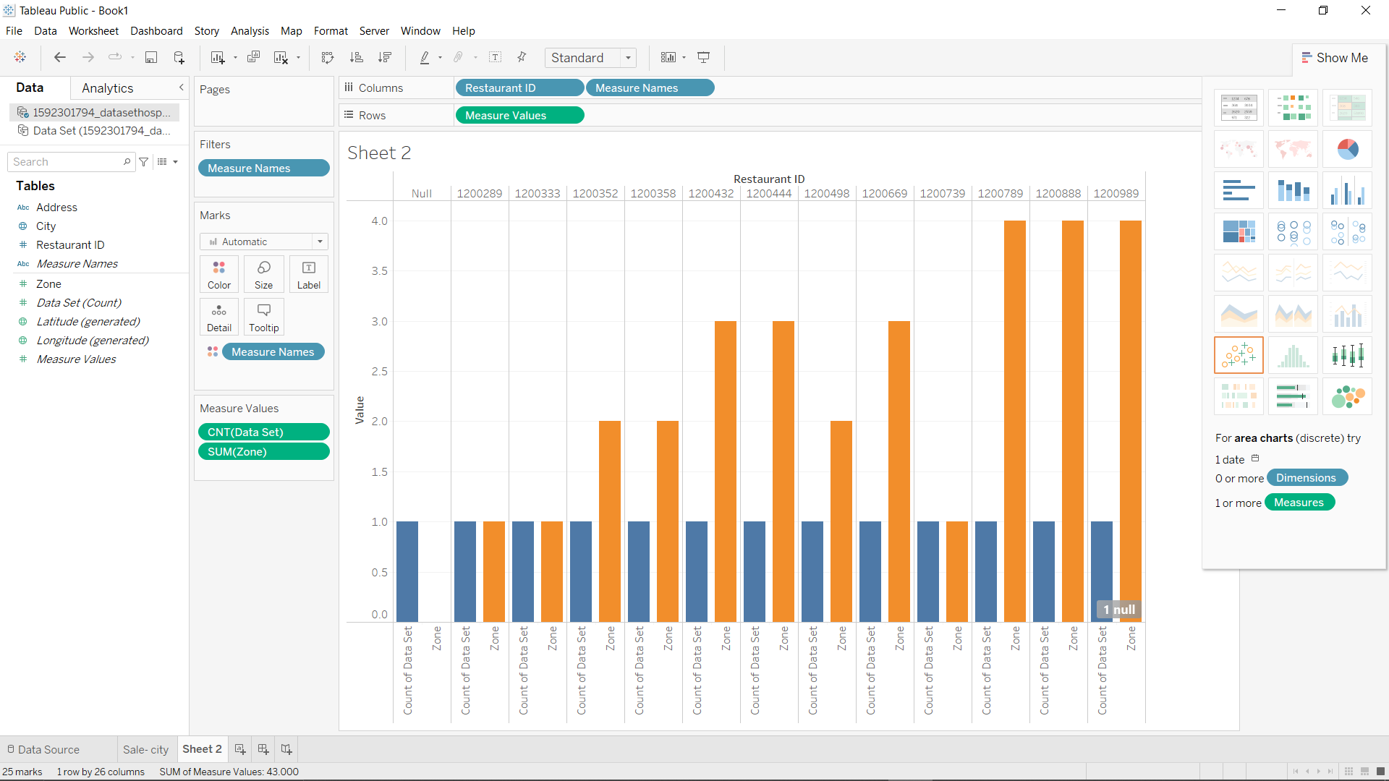

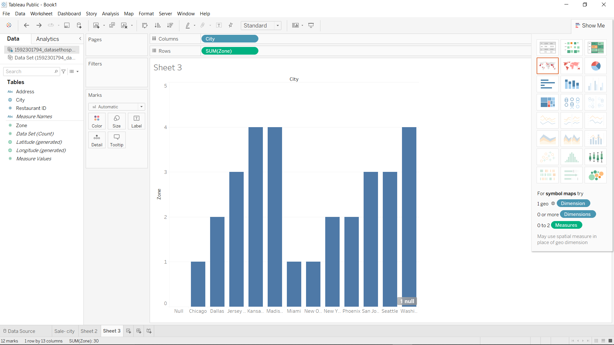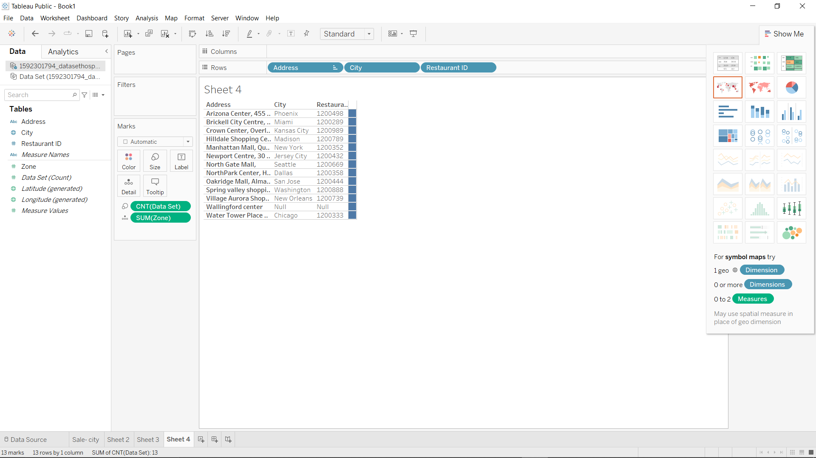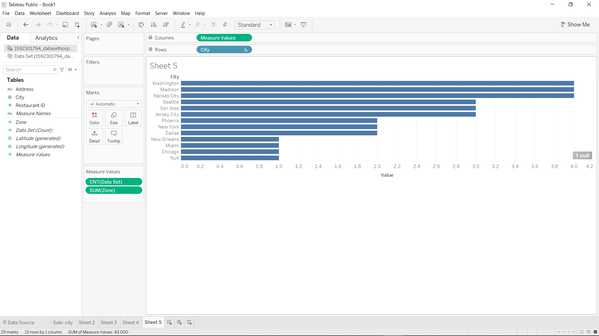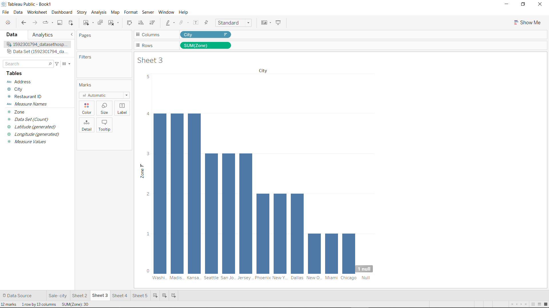

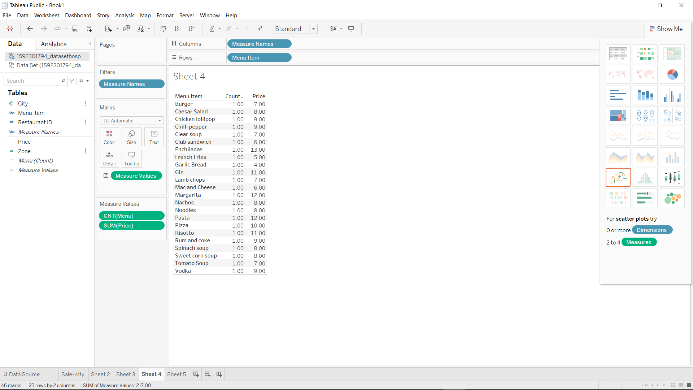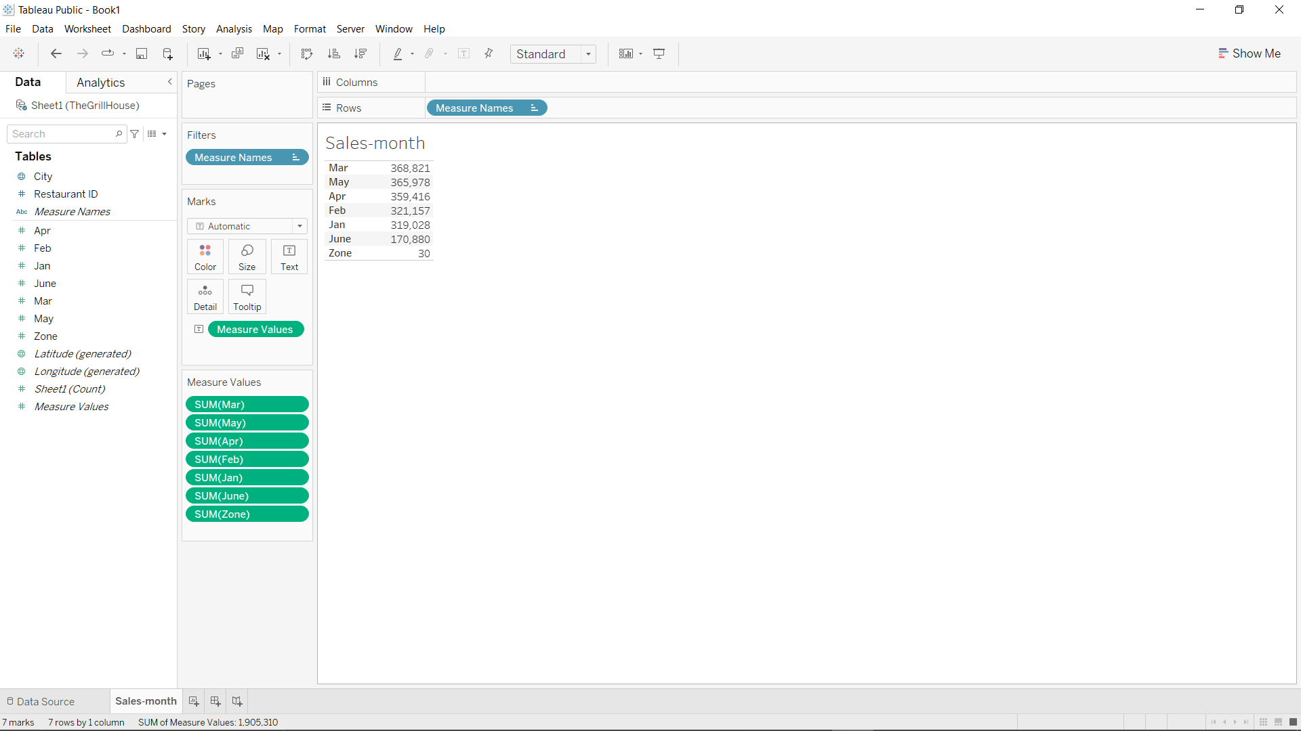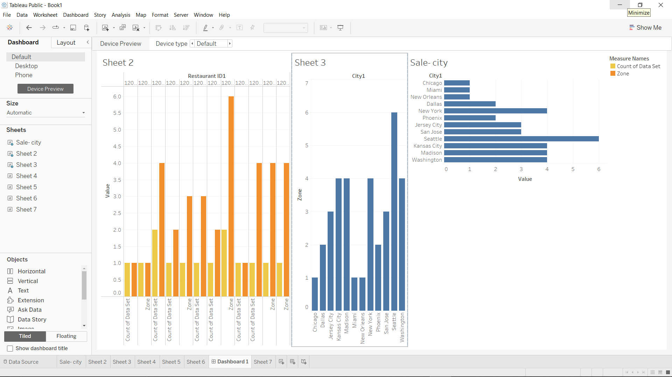

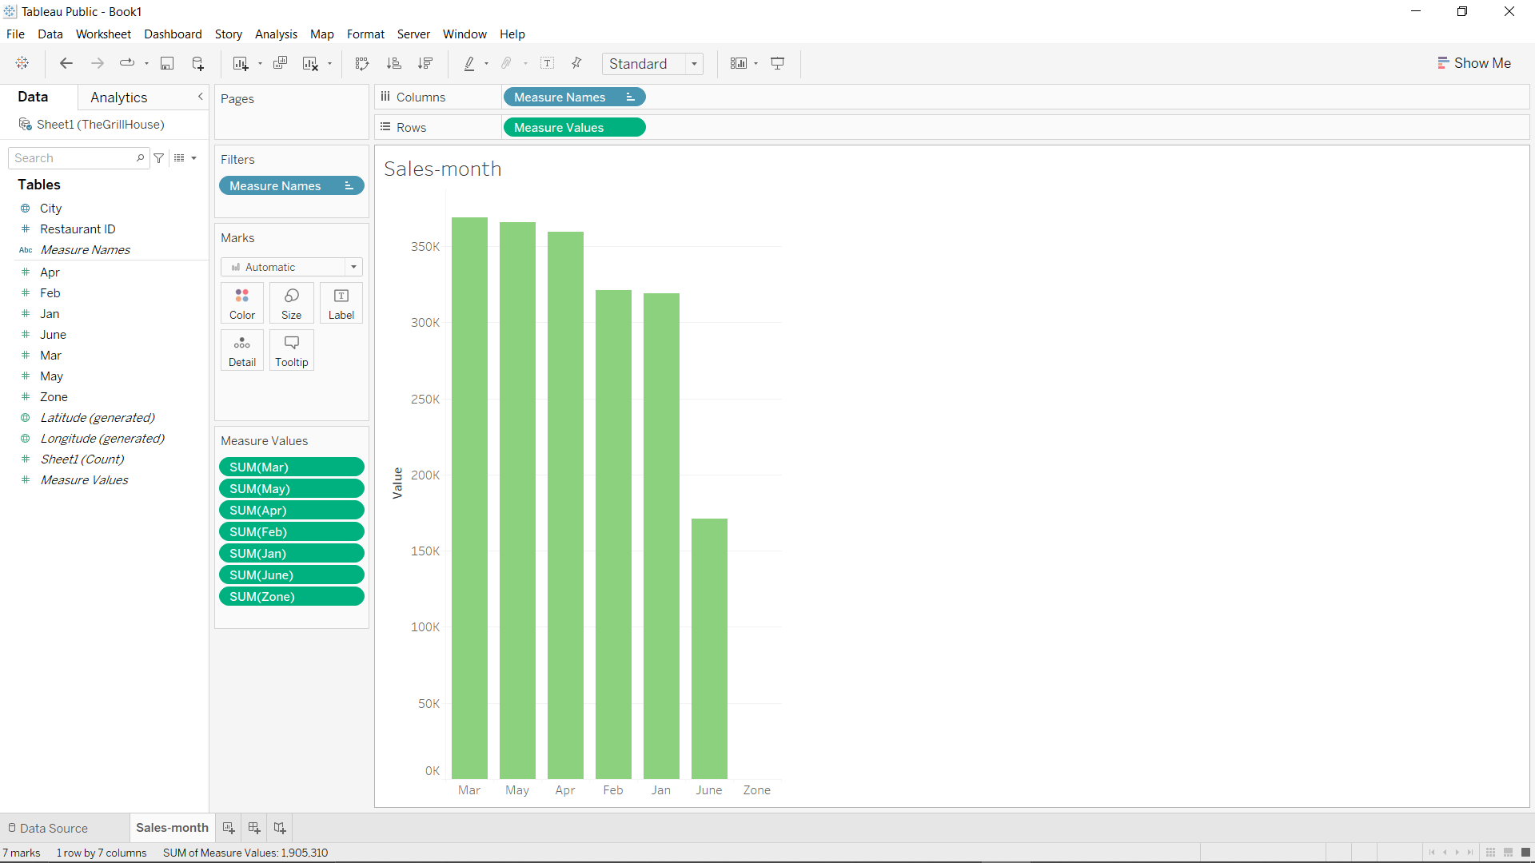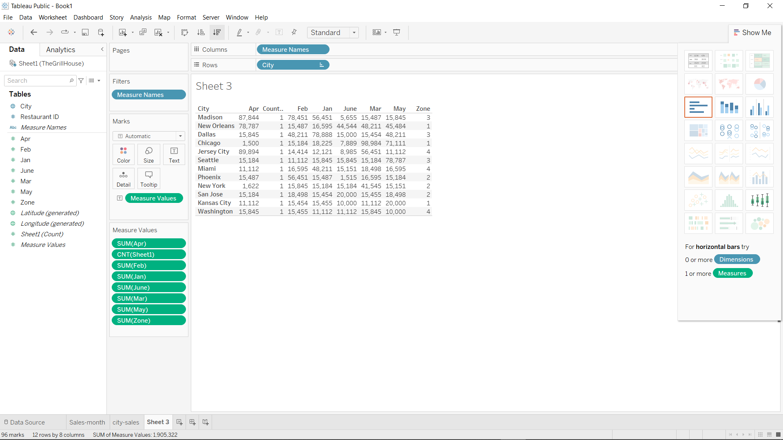

1. In the above chart for restaurant ID 1200789, find the sales for the month of June

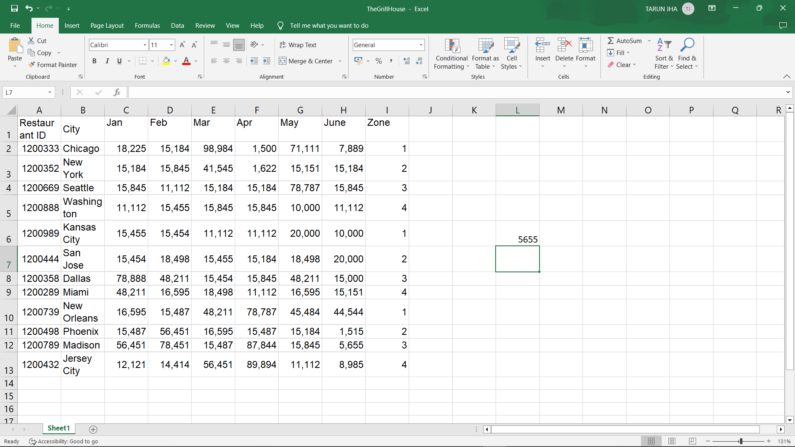

1. In the above chart for restaurant ID 1200739, find the sales for the month of April

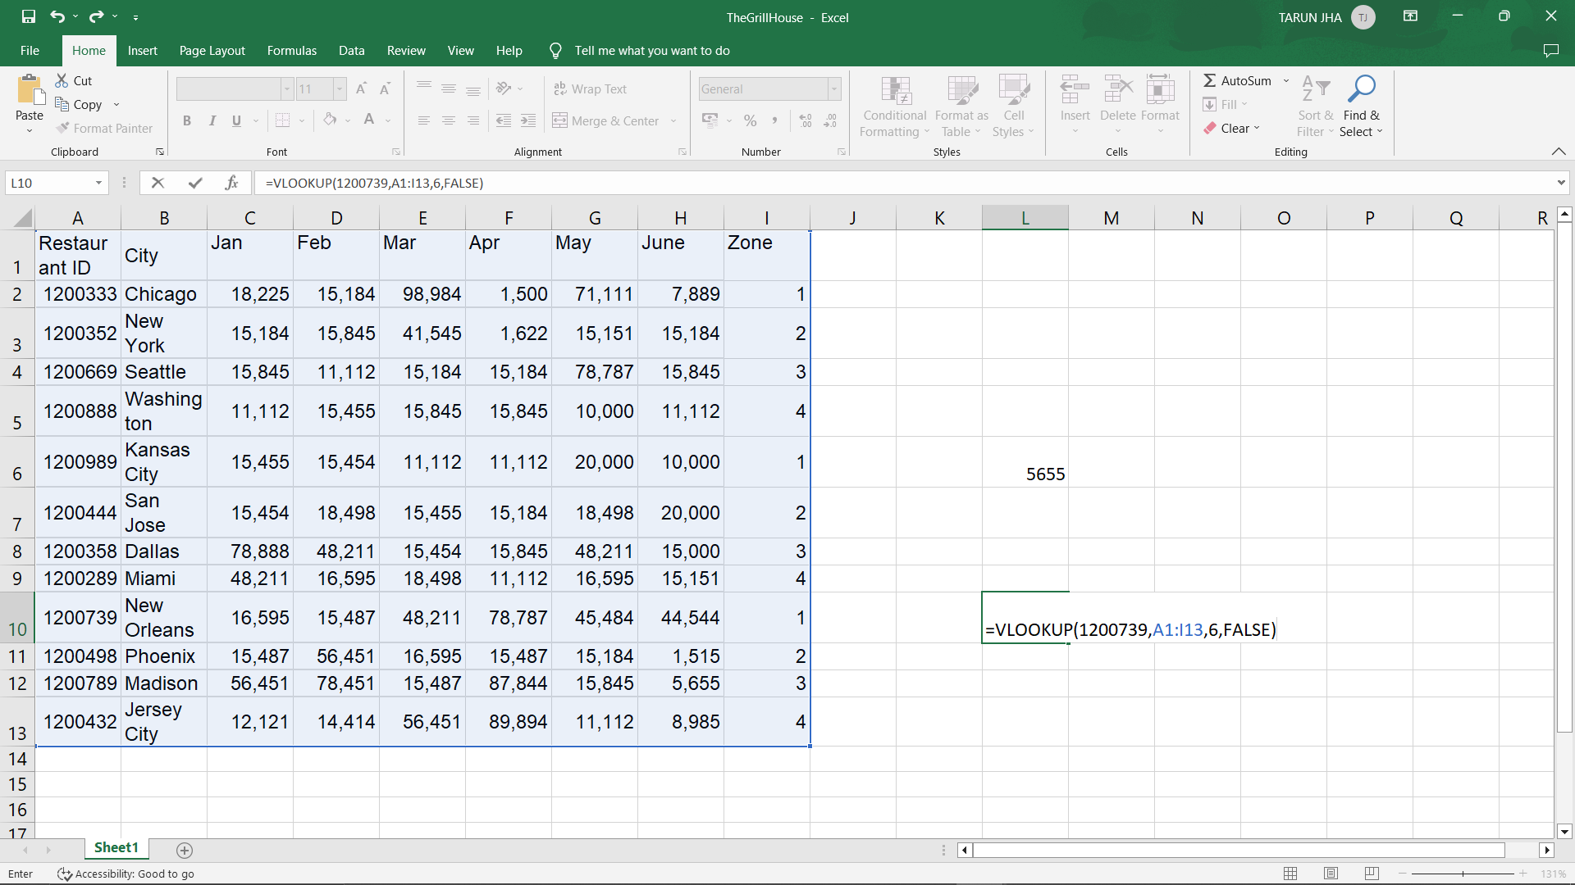

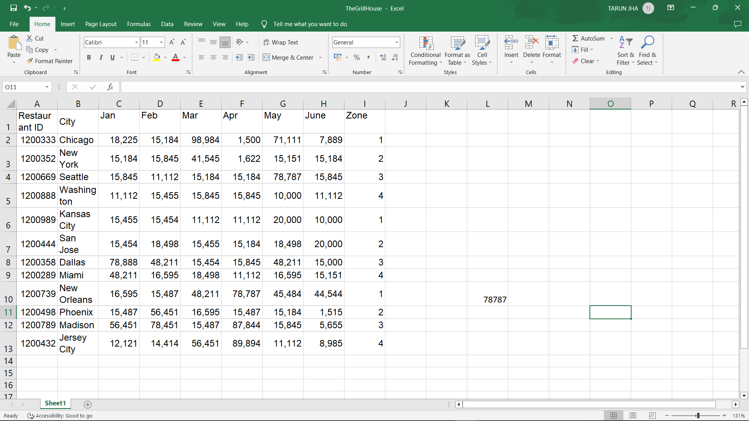

1. In the above chart for restaurant ID 1200352, find the sales for the month of January

